Exercise 1: Ranking and Window Functions
- Using ROW_NUMBER()
SELECT *
FROM (
SELECT
ProductID,
ProductName,
Category,
Price,
ROW_NUMBER() OVER (
PARTITION BY Category
ORDER BY Price DESC
) AS RowNum
FROM Products
) AS P
WHERE RowNum <= 3;

Output:

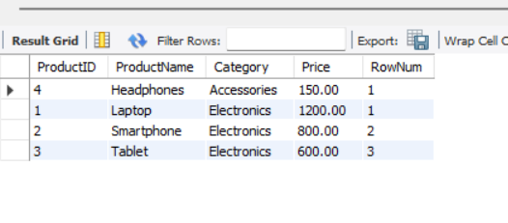

- Using RANK()
SELECT *
FROM (
SELECT
ProductID,
ProductName,
Category,
Price,
RANK() OVER (
PARTITION BY Category
ORDER BY Price DESC
) AS RankNum
FROM Products
) AS P
WHERE RankNum <= 3;

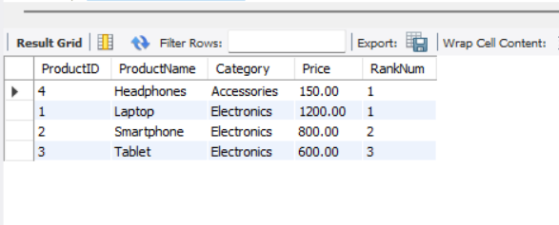

- Using DENSE_RANK()
SELECT *
FROM (
SELECT
ProductID,
ProductName,
Category,
Price,
DENSE_RANK() OVER (
PARTITION BY Category
ORDER BY Price DESC
) AS DenseRankNum
FROM Products
) AS P
WHERE DenseRankNum <= 3;

